# AVINASI GOUNDER MARIAMMAL COLLEGE OF EDUCATION

Erode-638 002, TamilNadu.

# *The Annual Quality Assurance Report (AQAR) of the IQAC for the Year of 2013-2014*

**Part – A**

**1. Details of the Institution**

**AVINASI GOUNDER MARIAMMAL COLLEGE OF EDUCATION**

**1.1 Name of the Institution**

12, Gandhiji Street

**1.2 Address Line 1**

Kollampalayam

Address Line 2

Erode

City/Town

Tamil Nadu

State

638 002

Pin Code

agmcoe@gmail.com

Institution e-mail address

0424-2401078

Contact Nos.

Mr.A. SIVAKUMAR

Name of the Head of the Institution:

0424-2401078

Tel. No. with STD Code:

Mobile:

98427 82848

Name of the IQAC Co-ordinator:

Mr.A.VAIYADURAI

Mobile:

99656 85611

agmiqac@gmail.com

IQAC e-mail address:

13425

1.3 **NAAC Track ID** *(For ex. MHCOGN 18879)*

1.4 **NAAC Executive Committee No. & Date:**

*(For Example EC/32/A&A/143 dated 3-5-2004.*

EC/65/A&A/69/ Dated 25-10-2013

*This EC no. is available in the right corner- bottom*

*of your institution’s Accreditation Certificate)*

www.agmcoe.ac.in

**1.5 Website address:**

. http://www.agmcoe.ac.in/Document/AQAR-2013-2014.docx

Web-link of the AQAR:

For ex. http://www.ladykeanecollege.edu.in/AQAR2012-13.doc

**1.6 Accreditation Details**

|  |  |  |  |  |  |
| --- | --- | --- | --- | --- | --- |
| Sl. No. | Cycle | Grade | CGPA | Year of Accreditation | Validity Period |
| 1 | 1st Cycle | B | 2.12 | 2013 | 2018 |
| 2 | 2nd Cycle | - | - | - | - |
| 3 | 3rd Cycle | - | - | - | - |
| 4 | 4th Cycle | - | - | - | - |

**1.7 Date of Establishment of IQAC :** DD/MM/YYYY

25/9/2013

**1.8 AQAR for the year *(for example 2010-11)***

**2013-2014**

**1.9 Details of the previous year’s AQAR submitted to NAACafterthe latest Assessment and Accreditation by NAAC (*(for example AQAR 2010-11submitted to NAAC on 12-10-2011)***

1. AQAR __________________NIL_____ __________________ (DD/MM/YYYY)4
2. AQAR__________________ ________________________ (DD/MM/YYYY)
3. AQAR__________________ _______________________ (DD/MM/YYYY)
4. AQAR__________________ _______________________ (DD/MM/YYYY)

**1.10 Institutional Status**

---

---

---

-

University State Central Deemed Private

----

Affiliated College Yes No

✓

Constituent College Yes No

---

---

Autonomous college of UGC Yes No

-

---

-

Regulatory Agency approved Institution Yes No

NCTE

(eg. AICTE, BCI, MCI, PCI, NCI)

--

--

✓

Type of Institution Co-education Men Women

Urban Rural Tribal

--

✓

--

--

Financial Status Grant-in-aid UGC 2(f) UGC 12B

-

--

✓

Grant-in-aid + Self Financing Totally Self-financing

--

**1.11 Type of Faculty/Programme**

-

-

Arts Science Commerce Law PEI (Phys Edu)

--

---

-

TEI (Edu) Engineering Health Science Management

--

--

--

✓

Others (Specify)

    -

**1.12 Name of the Affiliating University** *(for the Colleges)*

Tamil Nadu Teachers Education University, Chennai-5

**1.13 Special status conferred by Central/ State Government-- UGC/CSIR/DST/DBT/ICMR etc**

-

Autonomy by State/Central Govt. / University

University with Potential for Excellence UGC-CPE

-

-

-

-

DST Star Scheme UGC-CE

-

-

UGC-Special Assistance Programme DST-FIST

-

-

UGC-Innovative PG programmes Any other (*Specify*)

UGC-COP Programmes

-

**2. IQAC Composition and Activities**

2.1 No. of Teachers

5

1

2.2 No. of Administrative/Technical staff

1

2.3 No. of students

2.4 No. of Management representatives

1

1

2.5 No. of Alumni

2. 6 No. of any other stakeholder and

1

community representatives

-

2.7 No. of Employers/ Industrialists

1

2.8 No. of other External Experts

2.9 Total No. of members

11

2.10 No. of IQAC meetings held

3

**2.11 No. of meetings with various stakeholders:** No. Faculty

12

12

1

1

1

Non-Teaching Staff Alumni Others (Parents)

✓

-

**2.12 Has IQAC received any funding from UGC during the year?** Yes No

-

If yes, mention the amount

**2.13 Seminars and Conferences** (only quality related)

(i) No. of Seminars/Conferences/ Workshops/Symposia organized by the IQAC

1

1

-

-

2

Total Nos. International National State Institution Level

(ii) Themes

Themes and Variation in Educational Psychology

**2.14 Significant Activities and contributions made by IQAC**

* *Teaching quality improvement*
* *Research based work culture*
* The feedbacks obtained from students analyzed by the IQAC and the matters which need to be addressed to the respective staff members for implementation.
* Encouraging students to actively participate and get benefit in all the institutional activities.
* To conduct all committee meetings along with the IQAC members.
* IQAC plays vital role in this regard providing valuable inputs to staff members for quality enhancement of activities

**2.15 Plan of Action by IQAC/Outcome**

The plan of action chalked out by the IQAC in the beginning of the year towards quality enhancement and the outcome achieved by the end of the year

|  |  |
| --- | --- |
| **Plan of Action** | **Achievements** |
| 1. Tutorial ward system  2. Comprehensive Teaching  3. Quality enhancement programme | 1. Tutorial ward system followed  2. Teacher used modern strategies for teaching i.e. Power Point Presentation.  3. Innovative Teaching Methods such as LCD method Electronic interactive board teaching, NLIST programme |

***\* Attached the Academic Calendar of the year as Annexure- III***

**2.15 Whether the AQAR was placed in statutory body** Yes No

✓

✓

Management Syndicate Any other body

**2.16 Provide the details of the action taken**

AQAR submitted to management meeting. Based on the report the management made an action to the development of institution regarding Teaching Learning process, research based activities, social work and to arrange the skill development programme

Part – B

**CRITERION – I**

**1. CURRICULAR ASPECTS**

**1.1 Details about Academic Programmes**

|  |  |  |  |  |
| --- | --- | --- | --- | --- |
| Level of the Programme | Number of existing Programmes | Number of programmes added during the year | Number of self-financing programmes | Number of value added / Career Oriented programmes |
| PhD | - |  | - | **-** |
| PG | 1 |  | 1 | - |
| UG | 1 |  | 1 | - |
| PG Diploma | - |  | - | - |
| Advanced Diploma | - |  | - | - |
| Diploma | - |  | - | - |
| Certificate | - |  | - | 2 |
| Others | - |  | - | - |
| **Total** | 2 |  | 2 | 2 |

|  |  |  |  |  |
| --- | --- | --- | --- | --- |
| Interdisciplinary | - |  | - | - |
| Innovative | - |  | - | - |

**1.2 (i) Flexibility of the Curriculum: CBCS/Core/Elective option / Open options**

**Core / Elective /Options**

College is Affiliated to TNTEU Chennai. TamilNadu Teacher Education University framed the syllabus, and our institution follows the university curriculum. The students Performances are evaluated through continuous internal assessment for the core, elective and optional subjects. More options are given to the students while choosing the elective courses.

(ii) Pattern of programmes:

|  |  |
| --- | --- |
| Pattern | Number of programmes |
| Semester | - |  |  |  |
| Trimester | - |
| Annual | 2+2 |

**1.3 Feedback from stakeholders\*** Alumni Parents Employers Students

✓

✓

✓

✓

***(On all aspects)***

✓

Mode of feedback : Online Manual Co-operating schools (for PEI)

***\* *Provided analysis of the feedback details in annexure (I)***

**1.4 Whether there is any revision/update of regulation or syllabi, if yes, mention their salient aspects.**

Yes, the university revised the B.Ed curriculum in the year 2013-2014 onwards. The syllabus has been displayed in the Tamilnadu Teachers Education University ([**www.tnteu.in**](http://www.tnteu.in)) website for the access of the academic fraternity. The M.Ed course is followed the already existing syllabus.

**1.5 Any new Department/Centre introduced during the year. If yes, give details**.

**NO**

**CRITERION – II**

**2. TEACHING, LEARNING AND EVALUATION**

|  |  |  |  |  |
| --- | --- | --- | --- | --- |
| Total | Asst. Professors | Associate Professors | Professors | Others |
| 14 | 8 | 2 | 1 | 3 |

**2.1 Total No. of permanent faculty**

3

**2.2 No. of permanent faculty with Ph.D.**

|  |  |  |  |  |  |  |  |  |  |
| --- | --- | --- | --- | --- | --- | --- | --- | --- | --- |
| Asst. Professors | | Associate Professors | | Professors | | Others | | Total | |
| R | V | R | V | R | V | R | V | R | V |
| - | - | - | - | - | - | - | - | - | - |

**2.3 No. of Faculty Positions Recruited (R) and Vacant (V) during the year**

1

1

-

**2.4 No. of Guest and Visiting faculty and Temporary faculty**

**2.5 Faculty participation in conferences and symposia:**

|  |  |  |  |
| --- | --- | --- | --- |
| No. of Faculty | International level | National level | State level |
| Attended Seminars/ Workshops | 2 | 2 | - |
| Presented papers | - | - | - |
| Resource Persons | - | - | - |

**2.6 Innovative processes adopted by the institution in Teaching and Learning:**

We follow the innovative teaching approaches through Education technology like LCD, OHP, interactive electronic board, Net Connection, OPAC, and NLIST to enable the faculty to improve the teaching skills. This has created a great impact in improving the learning skills of students.

The live demonstration of hands on training to the students for communication development. The institution recognizes the faculty involved in innovative methods of teaching.

**2.7 Total No. of actual teaching days during this academic year**

200

**2.8** **Examination/ Evaluation Reforms initiated by**

Double Evaluation & CIA

**the Institution (for example: Open Book Examination, Bar Coding,**

**Double Valuation, Photocopy, Online Multiple Choice Questions)**

-

-

-

**2.9 No. of faculty members involved in curriculum**

**Restructuring/revision/syllabus development**

**as member of Board of Study/Faculty/Curriculum Development workshop**

97%

**2.10 Average percentage of attendance of students**

**2.11** **Course/Programme wise distribution of pass percentage :**

|  |  |  |  |  |  |  |
| --- | --- | --- | --- | --- | --- | --- |
| Title of the Programme | Total no. of students appeared | Division | | | | |
| Distinction % | I % | II % | III % | Pass % |
| B.Ed | 100 | 22 | 70 | - | - | 92 |
| M.Ed | 35 | - | 14 | 6 | - | 57 |
|  |  |  |  |  |  |  |

**2.12 How does IQAC Contribute/Monitor/Evaluate the Teaching & Learning processes:**

IQAC is contributing properly for the quality assurance in the educational programmes. IQAC has oriented the college faculty and the principal for quality enhancement in the academic programmes. IQAC is obtaining feedback from all the students. The IQAC is also monitoring the academic growth of the students from the weaker section of society. The principal with the team of faculty is continuously reviewing the teaching learning process of the college. IQAC is also monitoring the academic activities of the college.

**2.13 Initiatives undertaken towards faculty development**

|  |  |
| --- | --- |
| **Faculty / Staff Development Programmes** | **Number of faculty benefitted** |
| Refresher courses | - |
| UGC – Faculty Improvement Programme | - |
| HRD programmes | - |
| Orientation programmes | - |
| Faculty exchange programme | 1 |
| Staff training conducted by the university | 1 |
| Staff training conducted by other institutions | - |
| Summer / Winter schools, Workshops, etc. | 11 |
| Others | - |

**2.14 Details of Administrative and Technical staff**

|  |  |  |  |  |
| --- | --- | --- | --- | --- |
| Category | Number of Permanent  Employees | Number of Vacant  Positions | Number of permanent positions filled during the Year | Number of positions filled temporarily |
| Administrative Staff | 4 | - | - | - |
| Technical Staff | 1 | - | - | - |

**CRITERION – III**

**3. RESEARCH, CONSULTANCY AND EXTENSION**

**3.1 Initiatives of the IQAC in Sensitizing/Promoting Research Climate in the institution**

* Faculty members are encouraged to publish research papers in journals, attend the seminar, and symposium etc
* Action research are undertaken by our B,Ed., students for various problems and issues
* M.Ed Project work are undertaken by our M,Ed., students

**3.2 Details regarding major projects**

|  |  |  |  |  |
| --- | --- | --- | --- | --- |
|  | Completed | Ongoing | Sanctioned | Submitted |
| Number | - | - | - | - |
| Outlay in Rs. Lakhs | - | - | - | - |

**3.3 Details regarding minor projects**

|  |  |  |  |  |
| --- | --- | --- | --- | --- |
|  | Completed | Ongoing | Sanctioned | Submitted |
| Number | **-** | **-** | **-** | **-** |
| Outlay in Rs. Lakhs | **-** | **-** | **-** | **-** |

**3.4 Details on research publications**

|  |  |  |  |
| --- | --- | --- | --- |
|  | International | National | Others |
| Peer Review Journals | - | - | - |
| Non-Peer Review Journals | 1 | - | - |
| e-Journals | - | - | - |
| Conference proceedings | - | - | - |

Our College publishing an International Journal named as ***INTERNATIONAL JOURNAL PEDAGOGICAL STUDIES - IJPS and the ISSN No is 2321-2306***. It publishes annually with high-quality of articles and research papers in all areas of education.

**3.5 Details on Impact factor of publications:**

-

-

Range Average h-index Nos. in SCOPUS

-

-

**3.6 Research funds sanctioned and received from various funding agencies, industry and other organisations**

|  |  |  |  |  |
| --- | --- | --- | --- | --- |
| Nature of the Project | Duration  Year | Name of the  funding Agency | Total grant  sanctioned | Received |
| Major projects | - | - | - | - |
| Minor Projects | - | - | - | - |
| Interdisciplinary Projects | - | - | - | - |
| Industry sponsored | - | - | - | - |
| Projects sponsored by the University/ College | - | - | - | - |
| Students research projects  *(other than compulsory by the University)* | - | - | - | - |
| Any other(Specify) | - | - | - | - |
| Total | - | - | - | - |

* 1. **No. of books published** i) With ISBN No. Chapters in Edited Books

-

1

* Mr. A. Siva kumar, Asst. Professor in Bio-Science published a book on Environmental Science in the year 2014. The topic of the book is Environmental Education and the ISBN Numbers is 978-93-80024-35-6.

-

ii) Without ISBN No.

**3.8 No. of University Departments receiving funds from**

-

UGC-SAP CAS DST-FIST

-

-

-

-

DPE DBT Scheme/funds

-

-

-

**3.9 For colleges** Autonomy CPE DBT Star Scheme

INSPIRE CE Any Other (specify)

-

-

-

**3.10 Revenue generated through consultancy**

-

|  |  |  |  |  |  |
| --- | --- | --- | --- | --- | --- |
| Level | International | National | State | University | College |
| Number | - | - | 1  Work Shop | - | - |
| Sponsoring agencies | - | - | Management | - | - |

**3.11 No. of conferences organized by the Institution**

* State level work shop was conducted by our college. The expenses of the workshop was nearly Rs.90,000/ ie, for preparing invitation, postal charges, audio , video, writing materials, conveyance, momentous accommodation and honorarium.Other arrangements of seminar hall regarding workshop and remunaration for resource person and misllaneous expenses are included.
* Giving registration fees for faculty members to attend the seminar , workshop and symposium

**3.12 No. of faculty served as experts, chairpersons or resource persons:**

1

* Mr.P.Palanisamy, Asst.Professor in English acted as a resource person in DIET, Perundurai from 04.03.14 to 23.07.14. The DIET conducted free coaching classes for teacher eligibility test for specially challenged students; on that class he coached English and Social Science Subjects.

-

-

-

**3.13 No. of collaborations** International National Any other

-

**3.14 No. of linkages created during this year:**

**3.15 Total budget for research for current year in lakhs :**

1,50,000/-

-

From Funding agency From Management of University/College

Total

1,50,000/--

|  |  |  |
| --- | --- | --- |
| Type of Patent |  | Number |
| National | Applied | - |
| Granted | - |
| International | Applied | - |
| Granted | - |
| Commercialised | Applied | - |
| Granted | - |

**3.16 No. of patents received this**

**year**

**3.17 No. of research awards/ recognitions received by faculty and research fellows**

|  |  |  |  |  |  |  |
| --- | --- | --- | --- | --- | --- | --- |
| Total | International | National | State | University | Dist | College |
| **-** | **--** | - | - | - | - | - |

**Of the institute in the year**

**3.18 No. of faculty from the Institution**

-

**who are Ph. D. Guides**

**and students registered under them**

-

**3.19 No. of Ph.D. awarded by faculty from the Institution**

-

**3.20 No. of Research scholars receiving the Fellowships (Newly enrolled + existing ones)**

-

-

JRF SRF Project Fellows Any other

-

-

**3.21 No. of students Participated in NSS events:**

-

-

University level State level

International level National level

-

-

-

-

3.**22 No. of students participated in NCC events:**

-

-

University level State level

-

-

International level National level

**3.23 No. of Awards won in NSS:**

-

University level State level

-

International level National level

-

-

**3.24 No. of Awards won in NCC:**

University level State level

-

-

International level National level

-

-

**3.25 No. of Extension activities organized**

11

-

University forum College forum

-

NCC NSS Any other

-

-

**3.26 Major Activities during the year in the sphere of extension activities and Institutional Social Responsibility**

|  |  |  |  |  |
| --- | --- | --- | --- | --- |
| **S.No** | **Date** | **Programme** | **No. of Participants** | **Venue** |
| 1 | 18.12.2013 | General Medical camp | 100 Students + 1Doctor + 2 Nurses+ 30 public | College Premises |
| 2 | 6.01.2014 | Awareness of HIV (RRC) and De addiction programme | 100 Students + 3 Programme officers + 1 Doctor +25 Public | College Premises |
| 3 | 07.01.2014 | Awareness of First Aid | 100 Students + 2 Resource persons+27 Public | College Premises |
| 4 | 08.01.2014 | 1.Dental camp  2. Road safety awareness | 100 Students + 1 Camp officer+ 7 Doctors+ 22 Public  100 Students + 1 Resource person+17 Public | College Premises |
| 5 | 09.01.2014 | 1. Visit the Special school  2. Visit the old age home  3. Visit orphanage | 25 Students + 3 Faculty members  30 Students + 3 Faculty members  45 Students +3 Faculty members | Government School for Special children, Kollampalayam,, Erode.  Care centre, Thindal. Erode.  KarunaiIllam,  Rangampalayam.. |
| 6 | 09.01.2014 | Consumer awareness | 100 Students +1 resource person +28 Public | College Premises |
| 7 | 08.02.2014 | District level Chess Competition  ( Jointly organised by Our college and Erode District Chess association) | 150 Students + 15 resource persons+50 Public | College Premises |
| 8 | 09.03.2014 | Women’s day celebration | 100 Students + All faculty members+25Public | College Premises |
| 9 | 25.03.2014 | General sensational programme | 100 Students + 1 resource person+15Public | College Premises |
| 10 | 27.03.2014 | Voter awareness | 100 Students + 6 resource persons+23Public | College Premises |
| 11 | 11.05.2014 | Free Eye camp (Jointly organized by our college and Aravind Eye Hospital, Coimbatore) | 250 Public+3Doctors & Medical Assistance | College Premises |

**Women cell**

Women cell celebrated women’s day on 09th March 2013 in a grand manner with the special address by our principal Dr. K. Sumathiral. Our students performed wonderful cultural programme and also conducted food festival.

**Alumni Association**

Alumni association is functioning in our institution. Twice in a year we conduct the Alumni meet. The aim of this association is to provide a platform for the alumni to contribute towards the development of the Institution, Students and also Alumni members and society. It would also form an interface between the students and the alumni, who can advise, guide students and provide inputs to the endeavours of the students.

**CRITERION-IV**

**4. INFRASTRUCTURE AND LEARNING RESOURCES**

**4.1 Details of increase in infrastructure facilities**

|  |  |  |  |  |
| --- | --- | --- | --- | --- |
| **Facilities** | **Existing** | **Newly Created** | **Source of fund** | **Total** |
| Campus area | 5 acres | ---------------------- | A.G.M Trust | 5 acres |
| Class rooms | 6 (six) | ---------------------- | A.G.M Trust | 6 (six) |
| Laboratories | 7 (seven) | ---------------------- | A.G.M Trust | 7 (seven) |
| Seminar Halls | 2 (two) | --------------------- | A.G.M Trust | 2 (two) |
| No. of important equipments purchased (>_1-0lakhs)during the current year (Rs. in Lakhs) | *28* | 10 | A.G.M Trust | 38 |
| Value of the equipment purchased during the year (Rs .in Lakhs) | 7.5 | 3.5 | A.G.M Trust | 11.0 |
| Others | ---------- | 1.5 | A.G.M Trust | 1.5 |

**4.2 Computerization of administration and library**

AGM Library is partially automated OPAC with bar coding and Scanning, photocopying and circulation of books Issues/Return/Renewal For auto lib .Internet facilities is available in library to access e-Books, and e-journals, dissertations are available through INFLIBNET as per N-LIST Programme. Back Volume of Journals and Periodicals are available in our Library.

**4.3 Library Services**

|  |  |  |  |  |  |  |
| --- | --- | --- | --- | --- | --- | --- |
| **ITEMS** | **Existing** | | **Newly added** | | **Total** | |
| **No** | **value** | **No** | **Value** | **No** | **Value** |
| Text Books  Reference Books  e-Journals &e-books (NLIST)  Journals  CD&Video  Others(specify) | 5532  3027  2  15  160  ------- | 5,34,864  5,57,379  10,000  63264  1600  ------- | 41  169  1  ------  20  ----- | 10,641  34,39  5000  -------  200  ------- | 5573  3196  3  15  180  ----- | 5,45,505  5,91776  15,000  63,264  1800  ------- |

**4.4 Technology upgradation (overall)**

|  |  |  |  |  |  |  |  |  |
| --- | --- | --- | --- | --- | --- | --- | --- | --- |
|  | **Total Computers** | **Computer Labs** | **Internet** | **Browsing centres** | **Computer**  **Centres** | **office** | **Departments** | **others** |
| **Existing** | 28 | 1 | 3 | 28 | 1 | 2 | 2 | ------ |
| **Added** | 10 | ----- | ----- | ----- | ----- | ----- | ----- | ------ |
| **Total** | 38 | 1 | 3 | 28 | 1 | 2 | 2 | ------ |

**4.5 Computer ,Internet access, training to teachers and students and any other programme for technology Up gradation(Net working ,e-Governance etc)**

A.G.M Library has sophisticated instructional computing facilities which include INFLIBNET for N-LIST Programme .It is highly imperative for the Scholars, Students and Teaching Faculties to use the internet download their e-Books and e-Journals.

**4.6 Amount spent on maintenance in Lakhs:**

|  |
| --- |
| 3.5 Lakh |

|  |
| --- |
| 1.5 Lakh |

1. ICT

1. Campus Infrastructure &facilities

|  |
| --- |
| 0.5 |

1. Equipments

|  |
| --- |
| 1.5 Lakh |

iv) Others

|  |
| --- |
| 7.0 Lakhs |

**TOTAL**

CRITERION – V

**5. STUDENT SUPPORT AND PROGRESSION**

**5.1 Contribution of IQAC in enhancing awareness about Student Support Services**

* **Physically Challenged**
* The college is providing all possible assistance for them to get scholarships and bank loans for their educational assistance.
* The current year one B.Ed., student Mr. N.Rajendren is physically challenged. He can move like normal boys but slowly. The management arranged needed facilities for his learning and extracurricular activities.
* **SC/ST/OBC and Economically weaker sections**
* We are following the State government scholarship norms for these categories of students.
* The Government scholarships and institutional fees concession and SAI trust scholarships for majority students for SC/ ST/OBC students are arranged.
* Book bank in the library is serving their educational needs.
* Free coaching classes are conducted for them to appear for various entrance and competitive examinations.
* **Health centre**
* Separate health centre (room) with basic medical facilities and medicines are available to the students besides the medical camp. Doctor Mrs. Sudha Murugavel and Dr. Murugavel are visiting during working hours twice in a month.
* Our college conducted medical Camp on 18.12.13 our chief guest was Dr. Verrasivam. EMN clinic Erode.
* **Skill Development**
* The college is organizing various programmes for the Skill developments and Personality development.
* Willingness to learn new skills effective public speaking, our college was conducted the programme on 12.09.2013.
* **Fire Service Awareness**
* Our college conducted Fire service awareness programme on 10.01.2014. Our college invited fire safety officer Mr.Ramachandra as chief guest and conducted rally.
* **First Aid Awareness**
* Our college conducted First Aid Awareness programme on 07.01.2014. Our college invited chief guest Mr. S. Noel Jayaraj, St.Johns ambulance.
* **HIV/AIDS Awareness**
* Our college conducted HIV/AIDS Awareness programme on 06.01.2014. Our college invited chief guest Dr. Kumarasamy MBBS., DAV.
* **Alcohol and Drug Awareness**
* Our college conducted Alcohol and Drug Awareness programme on 06.01.2014. Our chief guest Mr.Gunasekar, Counsellor from Non Governmental organization care centre.
* **Dental Awareness**
* Our college conducted Dental Awareness programme on 08.01.2014 and presided by Dr.S.Sankar, and his team of Doctors of J.K.K.N. Dental college Komarapalayam
* **Road Safety Awareness**
* Our College conducted Road Safety Awareness Programme. National level Road Safety trainer Mr.R.N.P Ramanadhan was the chief guest.
* **Consumer Awareness**
* Our college conducted Consumer Awareness programme on 09.01.2014. Our chief guest Mr. Shanmugam, Advocate, Erode, oriented about consumer awareness.
* **Slow Learners**
* The Remedial coaching centre is conducting bridge course for the enhancement of skills to the slow learners.
* **Students Magazine**
* College is publishing yearly magazine and biannually News letter. The achievement of students and staff are highlighted.

**5.2 Efforts made by the institution for tracking the progression**

* Regular Observation
* Regular meetings / monitoring
* Regular feedback from students
* Education Technology Lab
* Language Lab
* Computer Lab

**5.3 (a) Total Number of students**

|  |  |  |  |
| --- | --- | --- | --- |
| UG | PG | Ph. D. | Others |
| 100 | 35 | - | - |

**(b) No. of students outside the state**

-

**(c) No. of international students**

-

|  |  |
| --- | --- |
| No | % |
| - | - |

|  |  |
| --- | --- |
| No | % |
| - | - |

Men Women

|  |  |  |  |  |  |  |  |  |  |  |  |
| --- | --- | --- | --- | --- | --- | --- | --- | --- | --- | --- | --- |
| Last Year | | | | | | This Year | | | | | |
| General | SC | ST | OBC | Physically Challenged | Total | General | SC | ST | OBC | Physically Challenged | Total |
| 01 | 22 | 03 | 73 | 01 | 100 | 01 | 20 | 01 | 78 | - | 100 |

Demand ratio 1.2 : 1 Dropout % NIL

**5.4 Details of student support mechanism for coaching for competitive examinations (If any)**

Free coaching classes are conducted for them to appear for various entrance and competitive examinations.

1. Teacher Eligibility Test
2. Teacher Recruitment Board (TRB)

No. of students beneficiaries

27

**5.5 No. of students qualified in these examinations**

-

-

-

-

NET SET/SLET GATE CAT

IAS/IPS etc State PSC UPSC Others

-

-

-

-

**5.6 Details of student counselling and career guidance**

The advancement in science and technology pose a lot of threat on the standard of living of human being and it demands enormous amount of adjustment. Today we face cut-throat competition due to which the cognitive and emotional resources of the humans suffer a lot. Life today is becoming increasingly complex. Stress has become an inevitable part of everyday life. It is a common notion that the present day younger generation when compared with previous generations are under more and different types of stress. This is due to increased pressure, competition, decreased resources for family support, increased access to means of self-harm, violence in the media and increased use of alcohol, drugs, etc. When coping resources are inadequate, stressful events may give rise to unhealthy outcomes. Stress or lack of coping resources may be one factor among many that leads to suicide.

Students in higher education face a lot of changes and challenges that can be very stressful. They may experience problems with peers, pursue a demanding academic overload and face tough competition. They have problems in decision-making especially in choosing a career within the available options. Also they experience problems in relationship, conflict with parents, friends and self-esteem and identity issues. They have to adjust themselves to the demands of the academic environment with reference to a constantly changing social environment. This poses a lot of stress on the students, which in turn make them to be de-motivated in their academic endeavour. Stress can affect the academic performance. Hence, they should be counselled to deal effectively with their day to day stress effectively. Many issues are under their control and the ability to prevent, control, manage their stress provide a great opportunity to learn new skills and promote personal growth.

The unit functions between 4 p.m to 6.p.m on all working days of the college. The students get these services by getting a prior appointment. Mr. A.sivakumar, Principal, Mr.A.Vaiyadurai, Mrs. S.Sridevi and V.Sandhya Assistant professors of the college guide and counsel clients. The following issues of students were addressed so far:

1. Depression
2. Memory Enhancement
3. Relationship Issues
4. Adjustment Problems

100

No. of students benefitted

**5.7 Details of campus placement**

|  |  |  |  |
| --- | --- | --- | --- |
| ***On campus*** | | | ***Off Campus*** |
| Number of Organizations Visited | Number of Students Participated | Number of Students Placed | Number of Students Placed |
| 05 | 84 | 41 | 12 |

**5.8 Details of gender sensitization programmes**

* The centre for women cell was conducting programmes for gender sensitization.
* Willingness to learn new skills effective public speaking, our college was conducted the programme on 12.09.2013.

**5.9 Students Activities**

**5.9.1 No. of students participated in Sports, Games and other events**

-

-

04

State/ University level National level International level

**No. of students participated in cultural events**

-

-

1

State/ University level National level International level

**5.9.2 No. of medals /awards won by students in Sports, Games and other events**

03

-

-

Sports : State/ University level National level International level

-

-

01

Cultural: State/ University level National level International level

**5.10 Scholarships and Financial Support**

|  |  |  |
| --- | --- | --- |
|  | Number of  students | Amount |
| Financial support from institution | 05 | 25,000 |
| Financial support from government | 31 | 14,78,500 |
| Financial support from other sources | 17 | 1,66,000 |
| Number of students who received International/ National recognitions | - | - |

**5.11 Student organised / initiatives**

-

-

-

Fairs : State/ University level National level International level

-

-

-

Exhibition: State/ University level National level International level

2

**5.12 No. of social initiatives undertaken by the students**

**5.13 Major grievances of students (if any) redressed: ____________NIL_________**

The grievance cell of our college is actively working. The suggestion box was fixed in the college campus. Students have some problems. They write the letter and post in the suggestion box. The grievance cell of the college is meeting twice in a week and receives complaints from the students and stake holders. The in-charge of the grievance cell and staff members discuses the complaints and take the remedial actions immediately.

**CRITERION – VI**

**6. GOVERNANCE, LEADERSHIP AND MANAGEMENT**

**6.1 State the Vision and Mission of the institution**

**Vision**

The College envisages, strive to constitute and proliferate knowledge as “Knowledge is power”. The vision of the college is represented in its emblem.

**Mission**

The mission is to create flawless pedagogical community by imparting sound education and educational teaching practice, and to produce quality teachers, as teachers form the backbone of the society.

**6.2 Does the Institution has a management Information System**

Administrative committee

Academic council Principal Correspondent Trust Secretary AGM Trust

**6.3 Quality improvement strategies adopted by the institution for each of the following:**

**6.3.1 Curriculum Development**

Our Institution affiliated to Tamil Nadu Teachers Education University. University revised the curriculum during the year of 2013-2014 with major input of current issues and needs of the learners. Our college followed the university syllabus accordingly. Our college also deputing the faculty to attend the orientation programme to update the knowledge of the new curriculum

**6.3.2 Teaching and Learning**

We fallow the innovative teaching approaches in our institution. For classroom teaching we use Interactive electronic Board, Educational CDs. Net connection facilities are established in the Education Technology lab, Computer lab, Language lab. All the labs are equipped with essential materials to enable the faculty and students to improve the teaching and learning skills for all method subjects. This has created a great impact on teaching learning process. The live demonstration of language skills hands on training students with language lab. The institution recognises the faculty involved in innovative method of teaching. The library facilities are strengthened with OPAC and NLIST programmes. Bar-coding and photocopy facilities to the students and faculty are added.

**6.3.3 Examination and Evaluation**

The Continues Internal Assessment (CIA) and its evaluation process are made transparent. All the students are given a chance to improve the CIA scores. Tutorial systems are followed. The staff members conducted unit test, midterm test and revision tests with standardised question papers. And also give the class seminar, assignments to the students. We also followed double valuation for test papers.

**6.3.4 Research and Development**

* Faculty members are motivated to apply for higher degree course and Research studies
* Workshops are organised with faculty members and invited experts from various institution.
* One of our faculty submitted Ph.D., thesis and 3 faculty members are pursuing Ph.D degree.

**6.3.5 Library, ICT and physical infrastructure / instrumentation**

Library has on advisory committee with management representative, Principal, staff members and students. One of the significant initiatives of the committee is to suggest to subscribe e-resources , books and journals. The library is partially automated with OPAC and Barcode systems. On line NLIST programmes are also available, Photocopying facility and net connection facility are also utilised by our faculty and learners.

The most recent coaching tool like interactive electronic board, LCD projectors, OHP projectors, computes are widely used for classroom training. Language lab is an important steps, in providing ICT enabled platform to the students to improve their communication skills.. Adoption of ICT, enabled modern teaching methods, has helped making teaching more interactive and effective. Our institution has well furnished ET, Computer lab, library, language lab with internet connectivity for the benefit of faculty and students.

The following infrastructure facilities are available in our institution, that is Principal room , administrative room, Method labs, ET lab, Computer lab, Language lab, Library, Resource rooms, Psychology lab, Seminar hall, Multipurpose hall, rest room, play grounds with sufficient materials.

**6.3.6 Human Resource Management**

Principal is the academic and administrative head of the institution. All files related to important decision like affiliation, admission, appointment etc are to be cleared only after the approval of principal.

The faculty of the each department are responsible for the academic programmes. Developing the instructional facilities for teaching learning process and motivating the students, and over all guidance, are the other duties of the faculty.

**6.3.7 Faculty and Staff recruitment**

Recruitment of faculty and non teaching staff is done on the basis of requirement by following the rules and regulation laid down by the NCTE, State government and Tamil Nadu teachers Education University. The staff selection committee consist of Principal, academic experts, concern subject experts, management representative

**6.3.8 Industry Interaction / Collaboration**

Nil

**6.3.9 Admission of Students**

The institution gives admission advertisement in the leading news papers. The applications received are processed by the respective staff members. The eligible applications are shortlisted based on merit. We strictly follow the admission procedures and guidelines issued by the Directorate of Collegiate Education, Government of Tamil Nadu and Tamil nadu Teachers Education University. We follow the communal reservation norms in the admission process. We also give special quota for the outstanding students from state level achievers in sports and games. And applicants are informed well in advance by the institution.

|  |  |
| --- | --- |
| Teaching |  |
| Non teaching |  |
| Students |  |

**6.4 Welfare schemes for**

* The wards of the employees are admitted to the courses offered in the college and our sister concerned institution with fee exemptions.
* Insurance to all the employees of this institution.
* Quarters for outstation staff.
* Scholar ships from Government and SAI trust, Chennai etc., for students

**6.5 Total corpus fund generated**

-

✓

**6.6 Whether annual financial audit has been done** Yes No

**6.7 Whether Academic and Administrative Audit (AAA) has been done?**

|  |  |  |  |  |
| --- | --- | --- | --- | --- |
| Audit Type | External | | Internal | |
| Yes/No | Agency | Yes/No  ✓ | Authority |
| Academic | ✓ | Academic experts |  | IQAC |
| Administrative | ✓ | Charted account | ✓ | Management |

**6.8 Does the University/ Autonomous College declares results within 30 days?**

-

-

For UG Programmes Yes No

-

-

For PG Programmes Yes No

**6.9 What efforts are made by the University/ Autonomous College for Examination Reforms?**

Nil

**6.10 What efforts are made by the University to promote autonomy in the affiliated/constituent colleges?**

Nil

**6.11 Activities and support from the Alumni Association**

Our institution has Alumini association. The aim of the Alumini association is to provide, a platform for the alumini to contribute towards the development of institution, students, alumini members and also society. It would also form an interface between the students and the alumini, who can advise, guide students and provide inputs to the endeavours of the students.

**6.12 Activities and support from the Parent – Teacher Association**

The parent - teacher association meeting have been conducted regularly. Teachers discus about the curricular and co-curricular activities, student’s regularity, discipline, their performance in exams and improvement to be carried out for the betterment of students. Comments and suggestions, feedback given by the parents are taken for consideration.

**6.13 Development programmes for support staff**

* We regularly conduct the meeting to support staff by Charted accountant and respective field experts to guide them to update knowledge of the respective fields
* Training in computer advancement for technical staff are given

**6.14 Initiatives taken by the institution to make the campus eco-friendly**

* Every year saplings are planted in all parts of the institution and also surroundings.
* We are having Eco club. Our Eco-club members maintain herbal garden with meditational value plants and flowers
* Usage of plastics is prohibited in our campus. The biological waste, are carefully discharged without harming the environment of the campus.
* Almost all the buildings of the campus are provided with pits for rain water harvesting.

**CRITERION – VII**

**7. INNOVATIONS AND BEST PRACTICES**

**7.1 Innovations introduced during this academic year which have created a positive impact on**

**the functioning of the institution. Give details.**

* Free coaching and counselling given to the students for various public Service Commission Examination and Teacher Eligibility Test.
* Free eye checkups given to the students and public.
* The institution conducted One day State level Workshop for teacher and student development.
* The innovative programmes created positive impact on the functions of our college among the society of below poverty line and rural students.

**7.2 Provide the Action Taken Report (ATR) based on the plan of action decided upon at the beginning of the year**

IQAC planned the objectives for the current year (2013 -2014) and its progress was monitored through action taken report by annually from all concerned persons. In this meeting these action taken reports were discussed and correction was done appropriately whenever it was required.

The action taken report included the following aspects:

* State Level Workshop
* International Research Journal Published
* The Faculty member presented the paper
* To equip all labs with latest equipments

**7.3 Give two Best Practices of the institution *(please see the format in the NAAC Self-study Manuals)***

**Annexure II**

***\*Provided the details in annexure (II)***

**7.4 Contribution to environmental awareness / protection**

* Our college conducts a green audit of the campus periodically. Our students are taking care of the tress in the college campus. Good Herbal garden is well maintained in the campus with novel varieties of herbal plants and flowers eco friendly.
* Our college organized fire prevention Rally programme on 10.1.2014 Mr. Ramachandran District Fire Safety Officer Erode was the Chief Guest on that occasion.
* Our College organized Road Safety awareness programme on 8.1.2014 Mr.N.Ramanathan National Road safety trainer Erode was the Chief Guest

**7.5 Whether environmental audit was conducted?** Yes No

✓

Environmental audit was conducted by eco club.

**7.6 Any other relevant information the institution wishes to add.**

**Strengths:**

#### Our college has pollution free environment

#### Necessary infrastructure facilities available

* Fully qualified, experienced and university approved staff members

**8. Plans of institution for next year**

* To strengthen the library facilities by subscribing to e-journals additionally.
* International seminar will be organized.
* Community based programmes will be organized.

* *

***Signature of the Coordinator, IQAC******Signature of the Chairperson, IQAC***

***Name:******Mr.A.VAIYADURAI Name: Mr.A.SIVAKUMAR***

*Assistant Professor in Physical Science Principal i/c*

*Avinasi Gounder Mariammal College of Education, Avinasi Gounder Mariammal College of Education,*

*Erode-2 Erode-2*

***ANNEXURE –I***

***ANALYSIS OF THE FEEDBACK-* Feedback on Faculty**

|  |  |  |  |
| --- | --- | --- | --- |
| **S.No** | **Subject** | **Sub.Code** | **Staff** |
| 1 | jkpo; fw;gpj;jypy; GJikfs; | UOIT | K.Santhanam (KS) |
| 2 | Content and Methods of Teaching English | UOCE | P.Palanisamy (PP) |
| 3 | Content and Methods of Teaching Mathematics | UOCM | S.Sridevi (SSD) |
| 4 | Content and Methods of Teaching Physical Science | UOCP | A.Vaiyadurai (AV) |
| 5 | Content and Methods of Teaching Biological Science | UOCB | A.Sivakumar (AS) |
| 6 | Content and Methods of Teaching History | UOCH | V.Sandhya (VS) |
| 7 | Content and Methods of Teaching Computer Science | UOCC | S.Senthil (SS) |
| 8 | Innovations in the Teaching of Commerce and Accountancy | UOA1 | K.Srividhya (KSV) |

Feedback received periodically from Students, Parents, Alumni & Employer. Once feedback is received, the Principal discusses various aspects related to all areas of the feedback and interacts one-to-one with each faculty member and analyzed.

**Teacher Effectiveness**

The graph represent that all faculty members have higher teaching effectiveness. All staff members have more or less equal teaching ability.

**Feedback of Alumni**

The overall rating of Alumni members feedback are found Very Good.

Comments put forward for the improvement of the functioning of the Institution

* Teachers’ more contribution in students’ Development
* More opportunities for placements
* More facilities to develop the learning ability.
* Teacher should give more guidance on students project.

**Feedback of Parent-Teacher Association**

Parent-Teacher Association meets annually. Suggestions and feedback from parents are positively welcomed and analyzed. Suitable remedial measures are implemented based on feedback.

**ANNEXURE**- II

1. **Give two best practices of the institution**

**Best Practices I**

**1. Title of the Practice**

To value educational programmes

**2. Objectives of the Practice**

* Periodic evaluation of faculty.
* Representations of experts in various academic bodies and obtain their suggestions.
* Admission of students by merit
* Providing access to INFLIBNET and other e-resources to the students and faculty members
* Encouraging the teachers by awards
* To ensure discipline by strictly following anti-ragging and maintaining the campus free from smoking.
* Pollution free campus

**3. The Context**

* Orienting the students to the Institutional standards.
* Providing uninterrupted power supply, water and other safety measures to the staff and students.
* Organizing various community oriented programmes. Resolving the issues related to the faculty and students.

**4. The Practice**

Enhancing the quality in teacher education is really a challenging task. Our college is situated in urban area but the students are coming from rural area and they are average or below average standards.

The economic conditions of students are also not sound and majority of the students are from poor family. Our college gets scholarships from the Government for ST & SC and SAI trust. We are adopting bilingual (Tamil/English) mode of instruction to help the rural students to understand the concepts of subjects. We are also providing reading materials and e-resources to them. Extra care is given to the below average students by conducting coaching and special classes.(Tutorial ward system)

**5. Evidence of Success**

The target is to ensure that the value oriented educational activities are utilized by the students and they should excel well in their career. This practice has yielded good results and the students of their subjects came out successfully in the campus recruiting interviews conducted by majority of the Schools.

**Best Practices II**

* Each and every class room activities are conducted by the faculty through ICT.
* Every student is given opportunities to take seminar through PowerPoint presentation.
* Special activities are being carried out for slow learners after class hour.
* Bright students are encouraged to participate in extracurricular activities within the college and inter college competitions.
* Special coaching for Teacher eligibility Test based on the subjects are being given.

**ANNEXURE – III**

**AVINASI GOUNDER MARIAMMAL COLLEGE OF EDUCATION, ERODE-2**

**TAMIL NADU TEACHERS EDUCATION UNIVERSITY**

**CALENDAR FOR THE ACADEMIC YEAR 2013-2014**

***(For all the colleges of education affiliated to this University)***

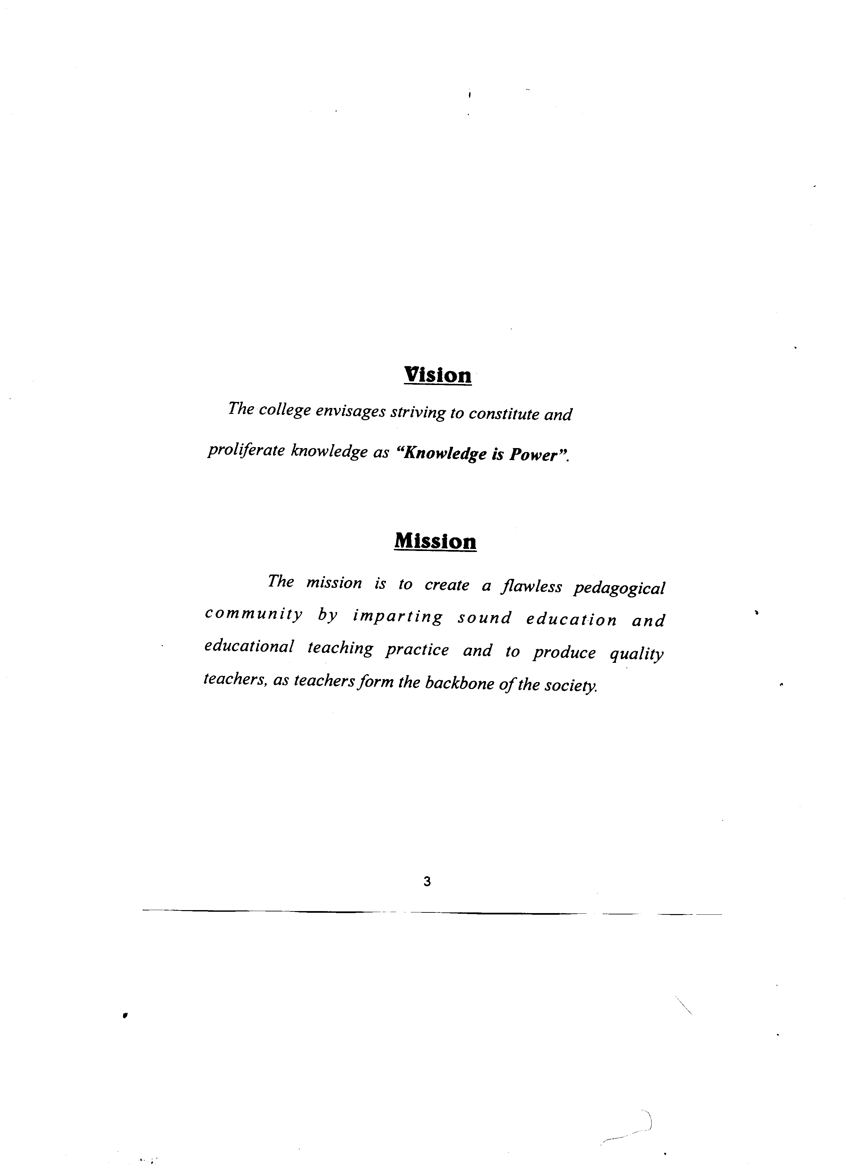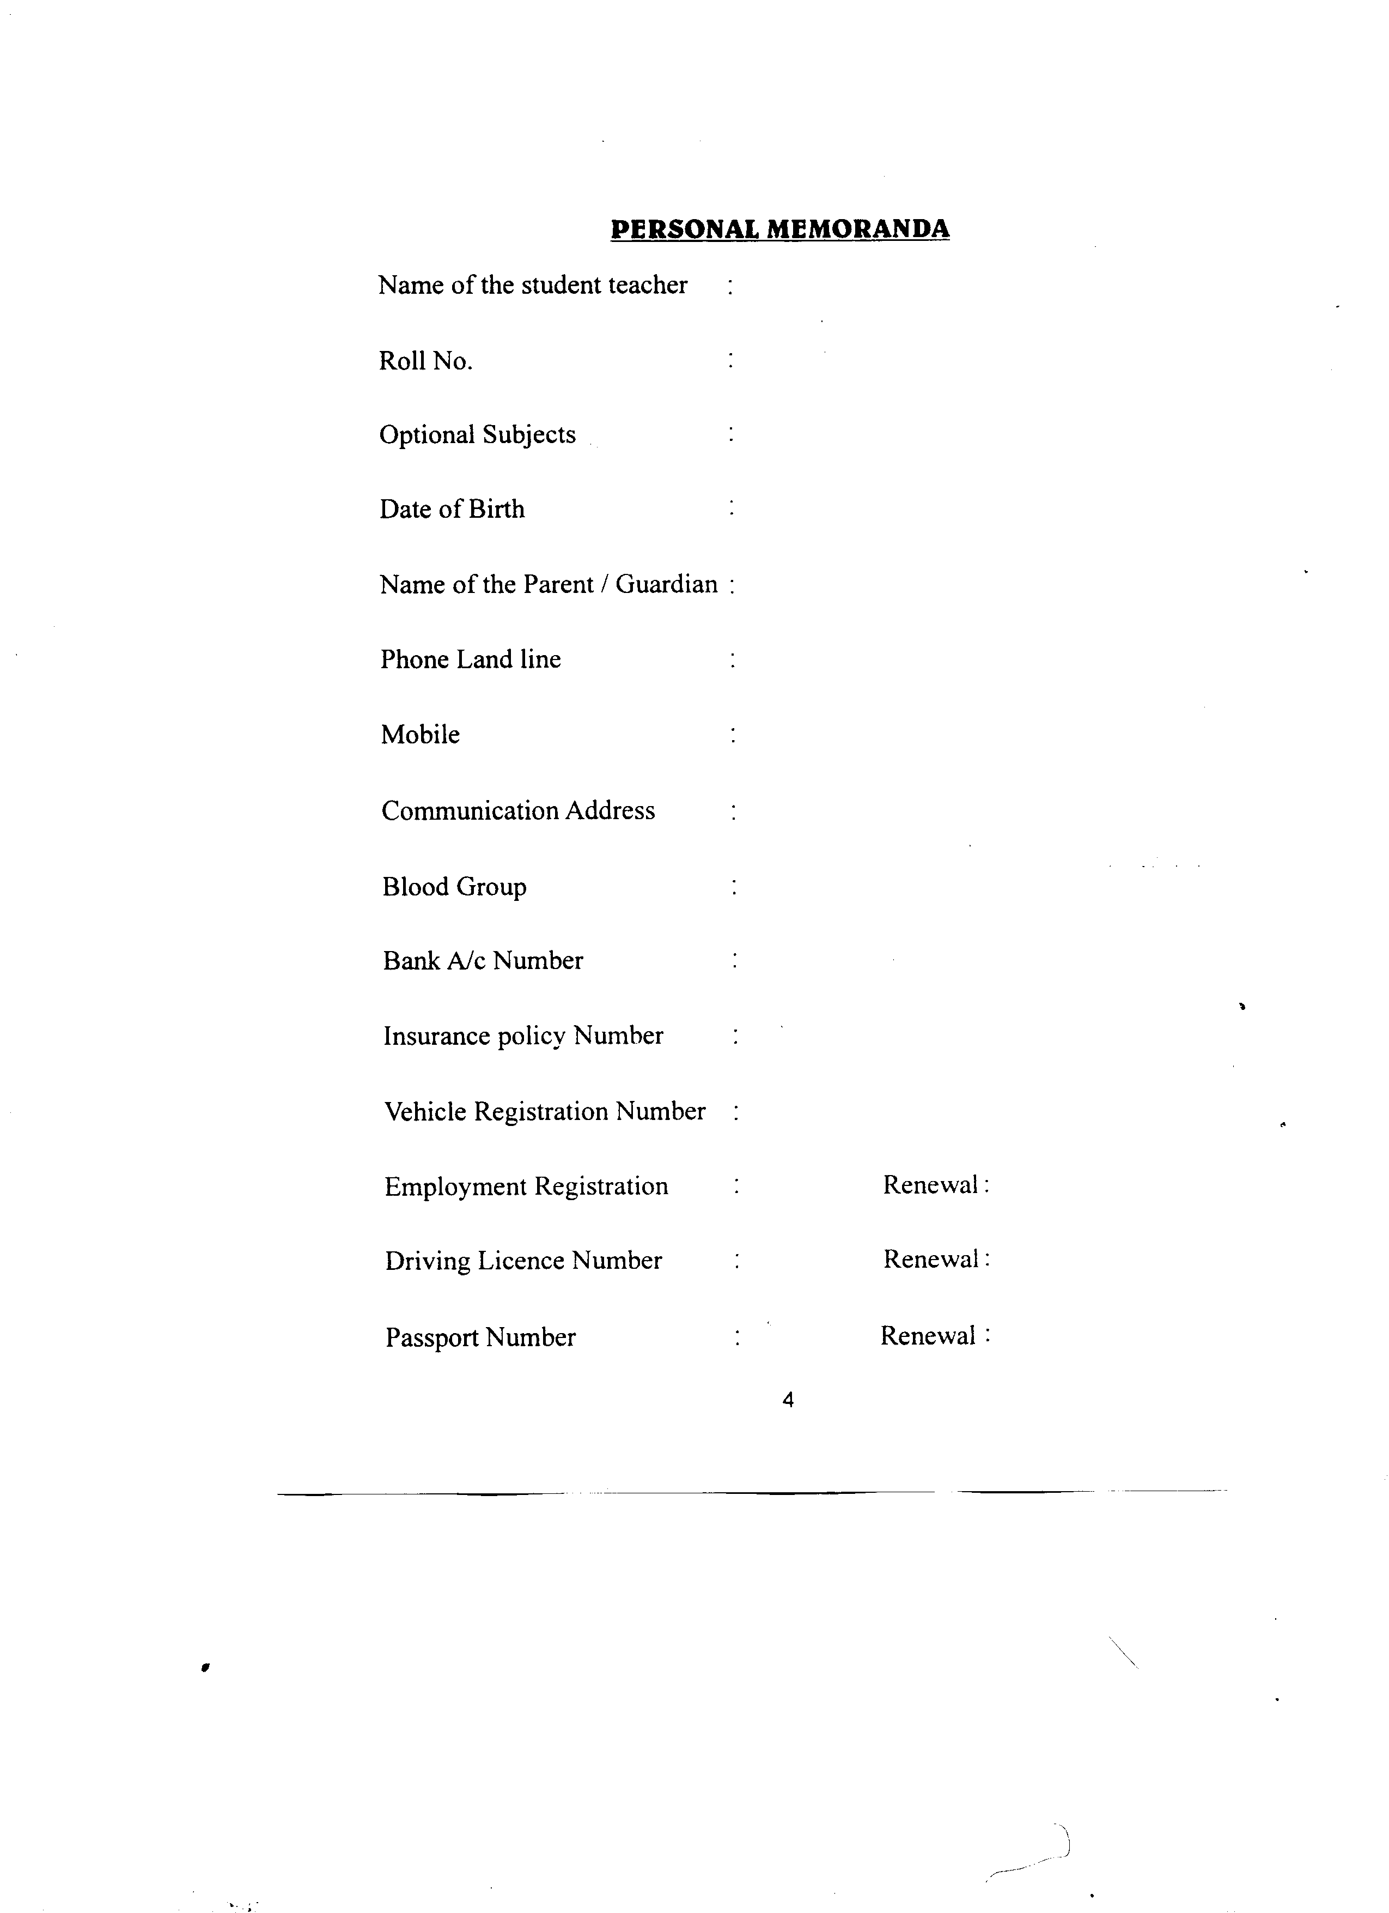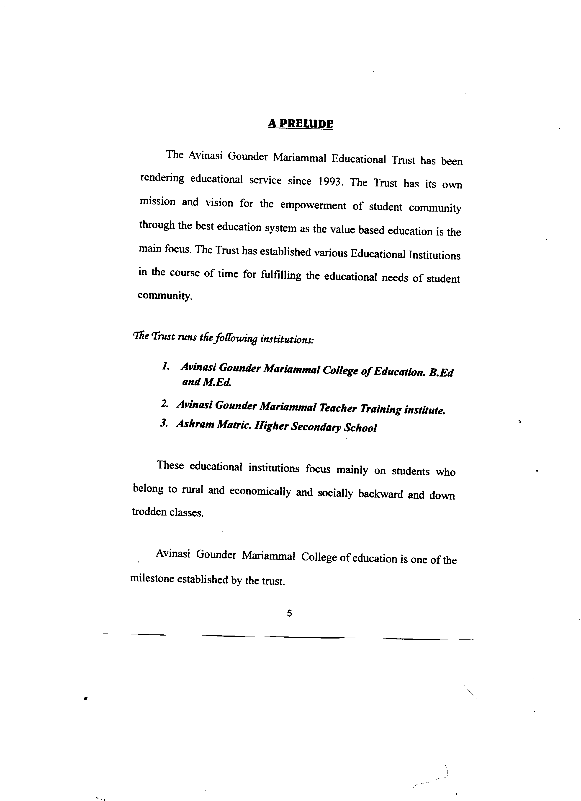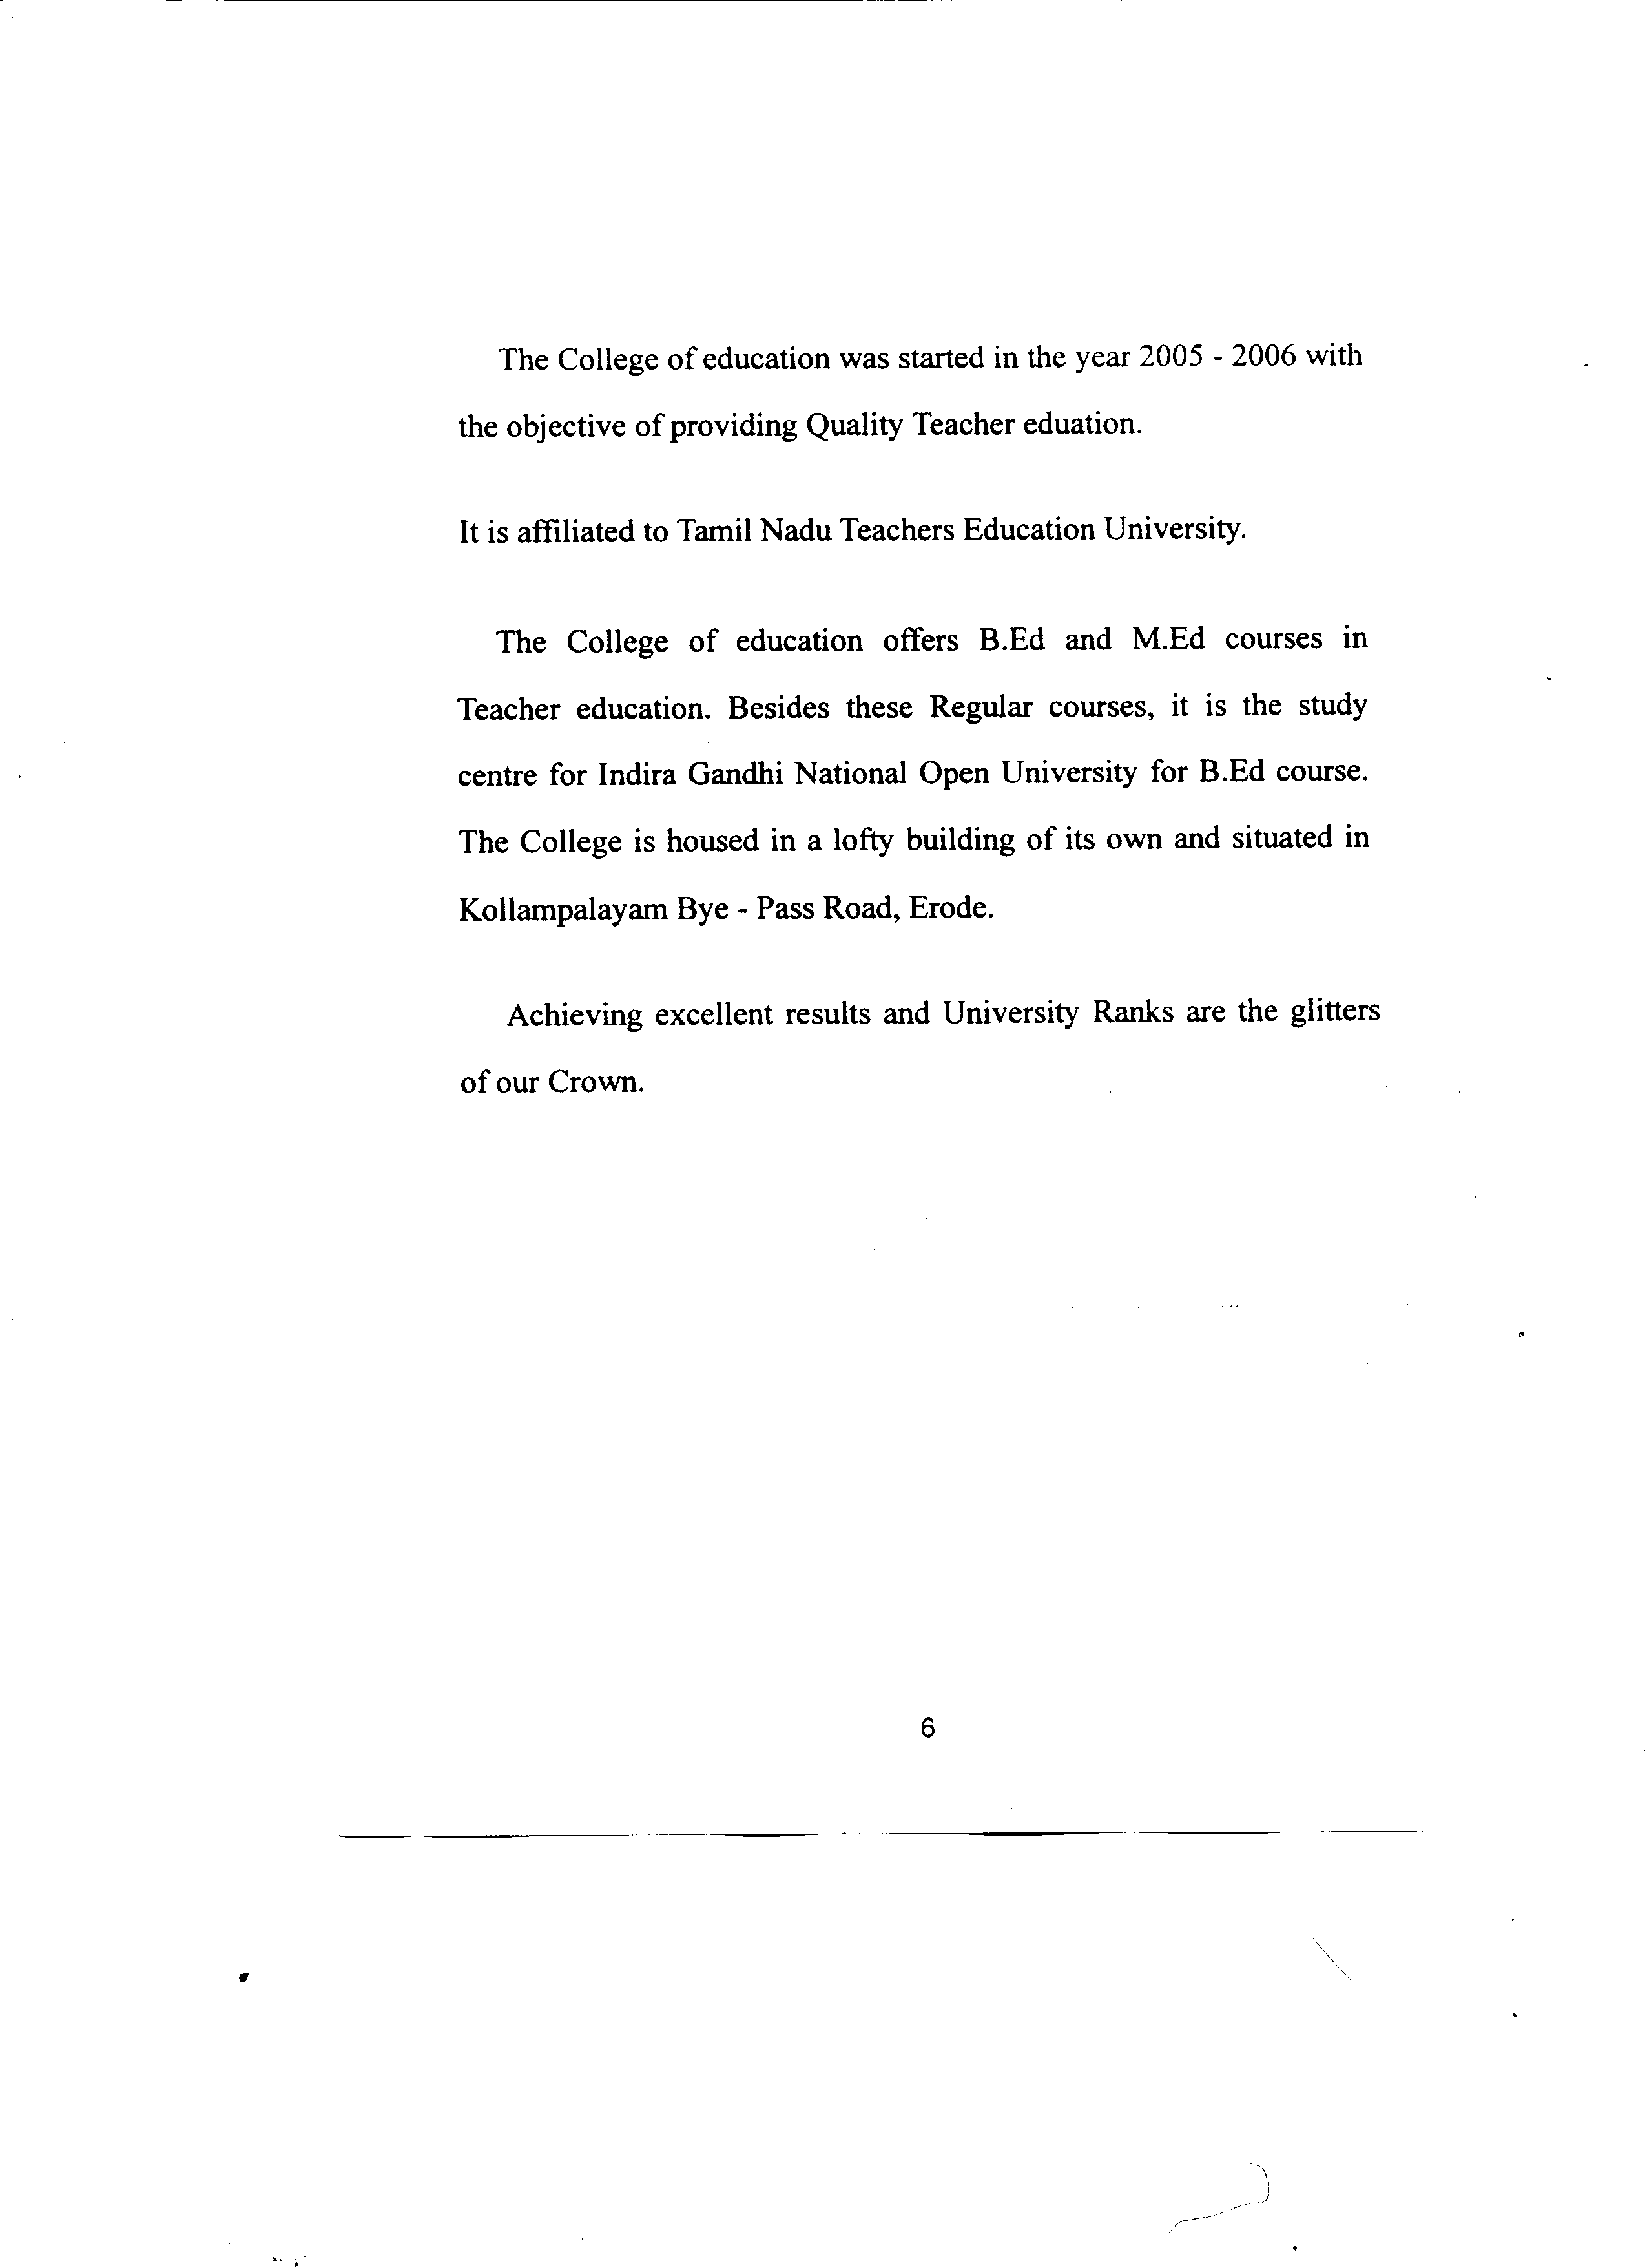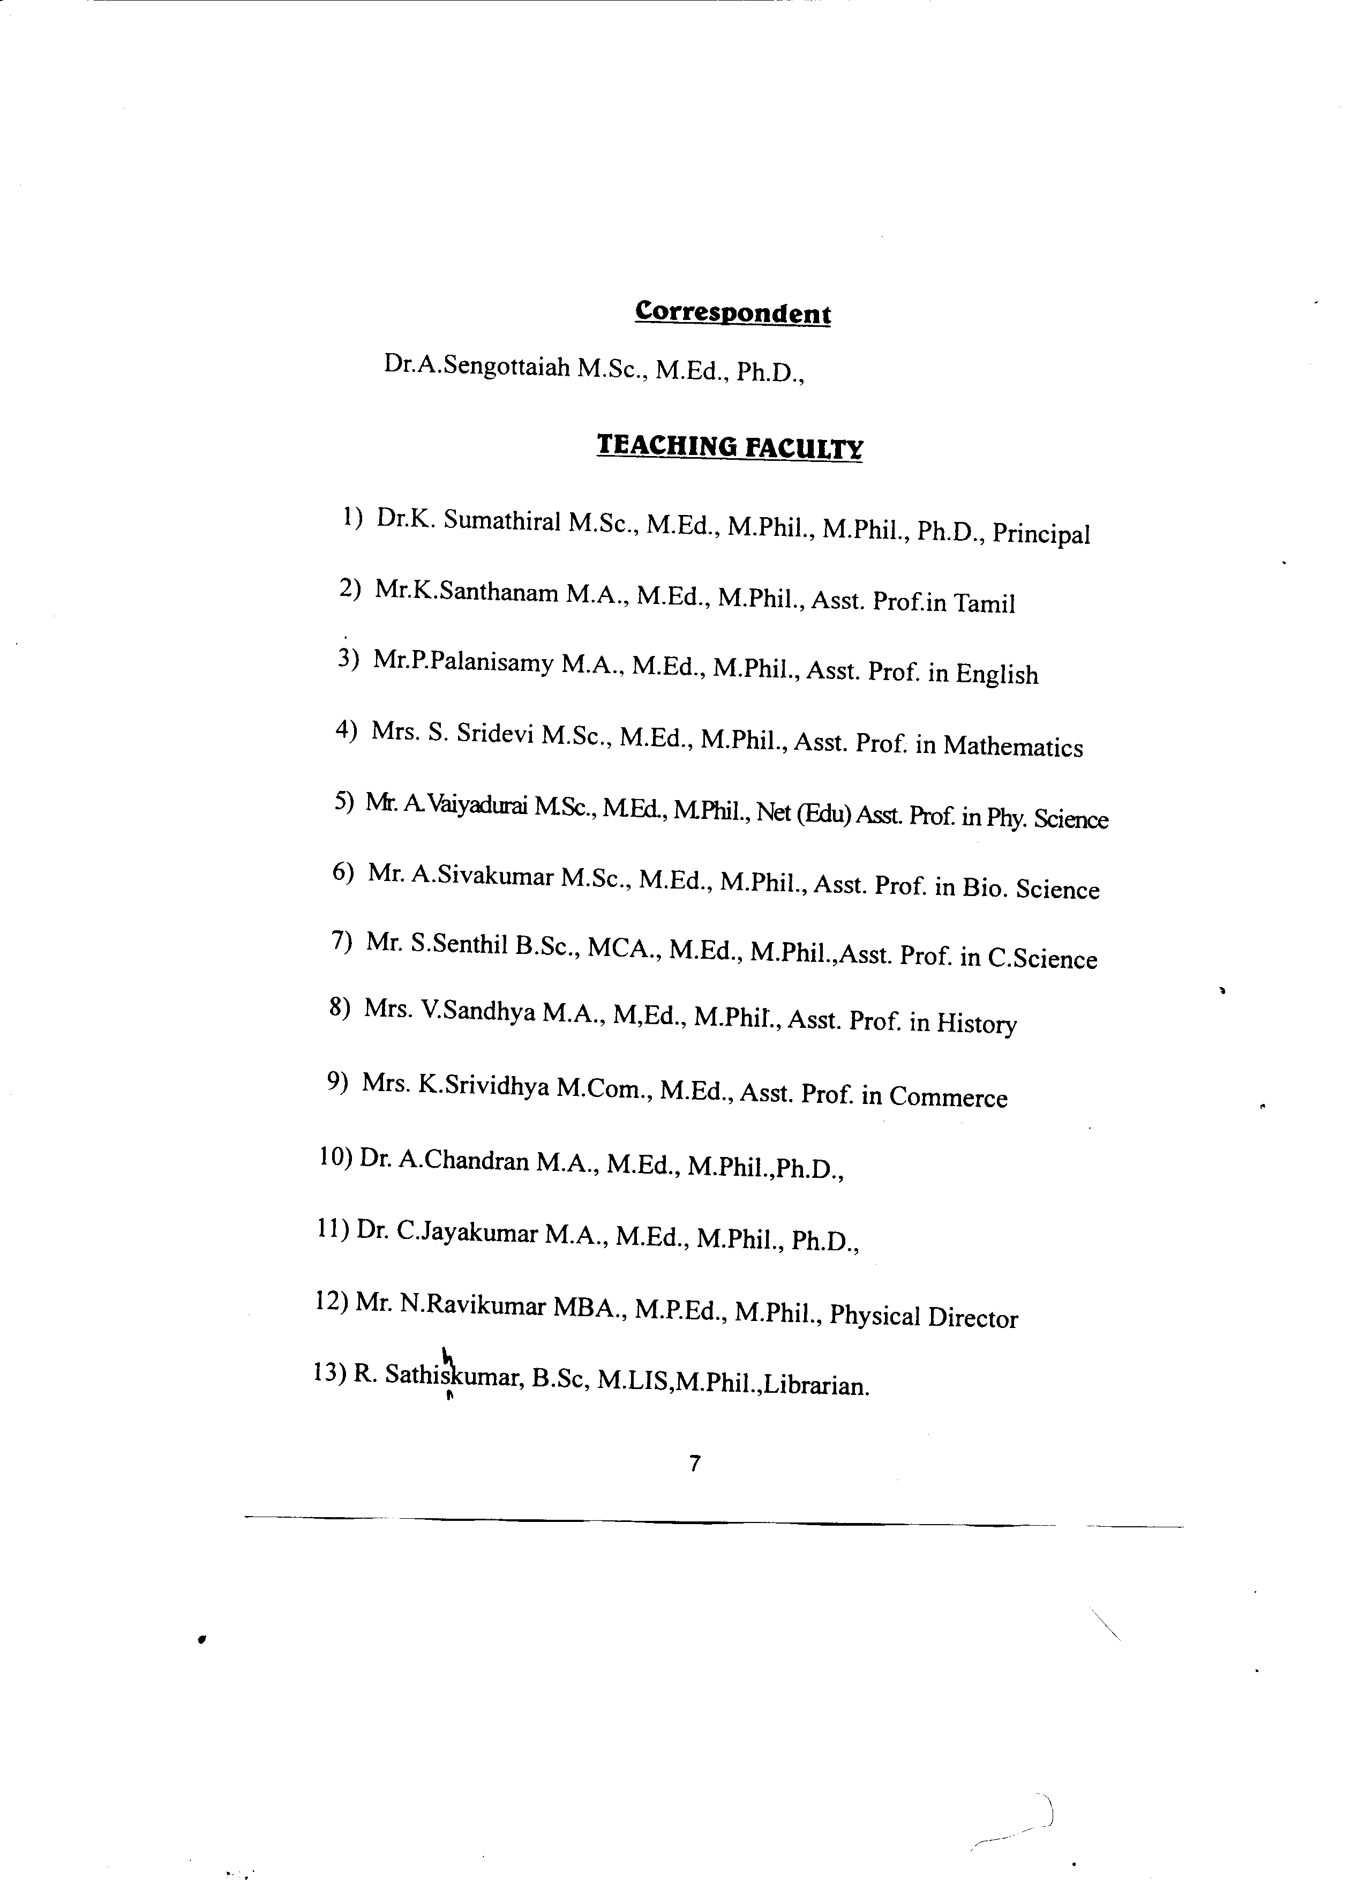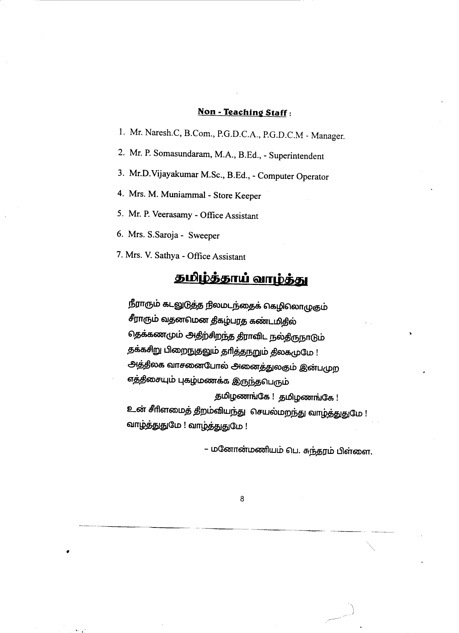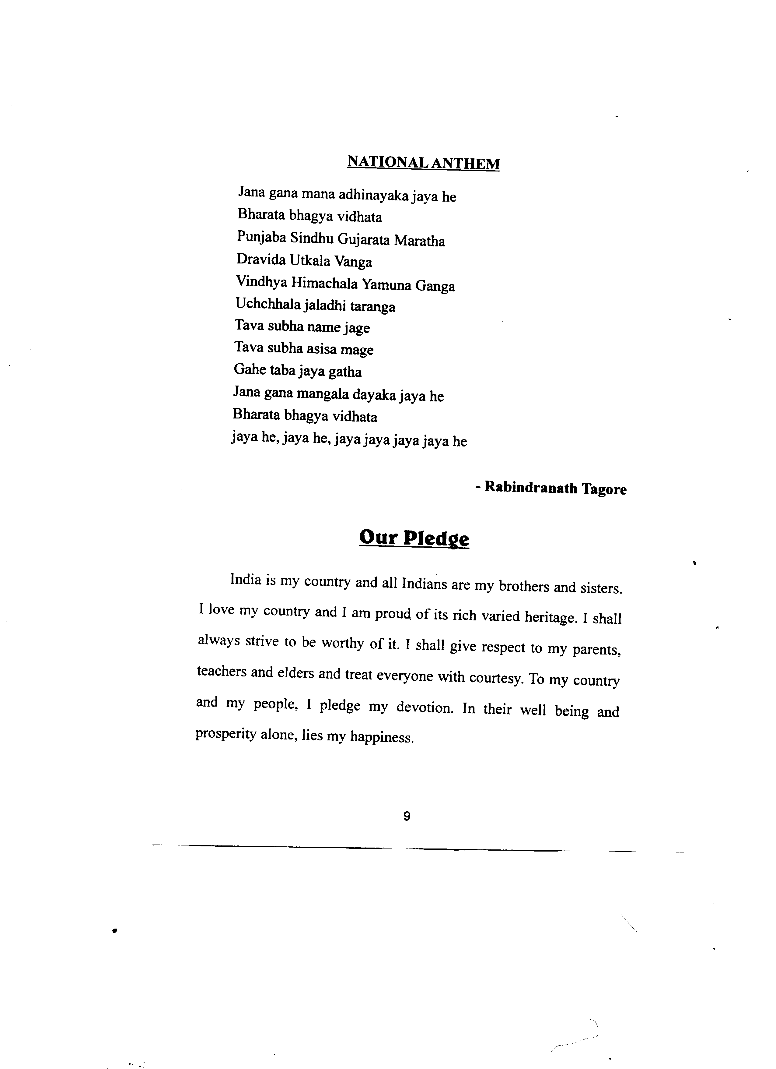******

**SEPTEMBER 2013**

|  |  |  |  |
| --- | --- | --- | --- |
| **Date** | **Day** | **Information** | **Working days** |
| 1. | Sunday | Holiday |  |
| 2. | Monday |  |  |
| 3. | Tuesday |  |  |
| 4. | Wednesday |  |  |
| 5. | Thursday | Teachers’ Day |  |
| 6. | Friday |  |  |
| 7. | Saturday |  |  |
| 8. | Sunday | Holiday |  |
| 9. | Monday | Holiday – Vinayakar |  |
|  |  | Chathurthi |  |
| 10. | Tuesday |  |  |
| 11. | Wednesday | Reopening of the colleges | 1 |
|  |  |  |  |
| 12. | Thursday |  | 2 |
| 13. | Friday |  | 3 |
| 14. | Saturday | Holiday |  |
| 15. | Sunday | Holiday |  |
| 16. | Monday | Micro-Teaching | 4 |
| 17. | Tuesday | “ | 5 |
| 18. | Wednesday | “ | 6 |
| 19. | Thursday | “ | 7 |
| 20. | Friday | “ | 8 |
| 21. | Saturday | “ | 9 |
| 22. | Sunday | Holiday |  |
| 23. | Monday | Micro-Teaching | 10 |
| 24. | Tuesday | “ | 11 |
| 25. | Wednesday |  | 12 |
| 26. | Thursday |  | 13 |
| 27. | Friday |  | 14 |
| 28. | Saturday |  | 15 |
| 29. | Sunday | Holiday |  |
| 30. | Monday |  | 16 |
|  |  | **Total** | **16 days** |

**OCTOBER 2013**

|  |  |  |  |
| --- | --- | --- | --- |
| **Date** | **Day** | **Information** | **Working days** |
| 1. | Tuesday |  | 17 |
| 2. | Wednesday | Holiday – Gandhi Jayanthi |  |
| 3. | Thursday |  | 18 |
| 4. | Friday |  | 19 |
| 5. | Saturday |  | 20 |
| 6. | Sunday | Holiday |  |
| 7. | Monday | Teaching Practice Begins | 21 |
| 8. | Tuesday |  | 22 |
| 9. | Wednesday |  | 23 |
| 10. | Thursday |  | 24 |
| 11. | Friday |  | 25 |
| 12. | Saturday | Holiday |  |
| 13. | Sunday | Holiday – Ayutha Pooja |  |
| 14. | Monday | Holiday – Vijayadasami |  |
| 15. | Tuesday | Last date for submission of | 26 |
|  |  | filled in Eligibility |  |
|  |  | Applications |  |
| 16. | Wednesday | Holiday - Bakrid |  |
| 17. | Thursday |  | 27 |
| 18. | Friday |  | 28 |
| 19. | Saturday |  | 29 |
| 20. | Sunday | Holiday |  |
| 21. | Monday |  | 30 |
| 22. | Tuesday |  | 31 |
| 23. | Wednesday |  | 32 |
| 24. | Thursday |  | 33 |
| 25. | Friday |  | 34 |
| 26. | Saturday |  | 35 |
| 27. | Sunday | Holiday |  |
| 28. | Monday |  | 36 |
| 29. | Tuesday |  | 37 |
| 30. | Wednesday |  | 38 |
| 31. | Thursday | Last date for applying for | 39 |
|  |  | continuation |  |
|  |  | affiliation for the subsequent |  |
|  |  | year |  |
|  |  | **Total** | **23 days** |

**NOVEMBER 2013**

|  |  |  |  |
| --- | --- | --- | --- |
| **Date** | **Day** | **Information** | **Working days** |
| 1. | Friday |  | 40 |
| 2. | Saturday | Holiday - Deepavali |  |
| 3. | Sunday | Holiday |  |
| 4. | Monday |  | 41 |
| 5. | Tuesday |  | 42 |
| 6. | Wednesday |  | 43 |
| 7. | Thursday |  | 44 |
| 8. | Friday |  | 45 |
| 9. | Saturday | Holiday |  |
| 10. | Sunday | Holiday |  |
| 11. | Monday |  | 46 |
| 12. | Tuesday |  | 47 |
| 13. | Wednesday |  | 48 |
| 14. | Thursday | Holiday – |  |
|  |  | Muhharam/Children’s Day |  |
| 15. | Friday |  | 49 |
| 16. | Saturday |  | 50 |
| 17. | Sunday | Holiday |  |
| 18. | Monday |  | 51 |
| 19. | Tuesday |  | 52 |
| 20. | Wednesday |  | 53 |
| 21. | Thursday |  | 54 |
| 22. | Friday |  | 55 |
| 23. | Saturday |  | 56 |
| 24. | Sunday | Holiday |  |
| 25. | Monday |  | 57 |
| 26. | Tuesday |  | 58 |
| 27. | Wednesday |  | 59 |
| 28. | Thursday |  | 60 |
| 29. | Friday |  | 61 |
| 30. | Saturday |  | 62 |
|  |  | **Total** | **23 days** |

**DECEMBER 2013**

|  |  |  |  |
| --- | --- | --- | --- |
| **Date** | **Day** | **Information** | **Working days** |
| 1. | Sunday | Holiday |  |
| 2. | Monday |  | 63 |
| 3. | Tuesday |  | 64 |
| 4. | Wednesday |  | 65 |
| 5. | Thursday |  | 66 |
| 6. | Friday |  | 67 |
| 7. | Saturday |  | 68 |
| 8. | Sunday | Holiday |  |
| 9. | Monday |  | 69 |
| 10. | Tuesday |  | 70 |
| 11. | Wednesday |  | 71 |
| 12. | Thursday | Supplementary examination | 72 |
|  |  | for the arrear candidates begin |  |
| 13. | Friday |  | 73 |
| 14. | Saturday | Holiday |  |
| 15. | Sunday | Holiday |  |
| 16. | Monday |  | 74 |
| 17. | Tuesday |  | 75 |
| 18. | Wednesday | Medical camp | 76 |
| 19. | Thursday | First Midterm Test | 77 |
| 20. | Friday | “ | 78 |
| 21. | Saturday | “ | 79 |
| 22. | Sunday | Holiday |  |
| 23. | Monday | First Midterm Test | 80 |
| 24. | Tuesday | “ | 81 |
| 25. | Wednesday | Holiday - Christmas |  |
| 26. | Thursday | First Midterm Test | 82 |
| 27. | Friday |  | 83 |
| 28. | Saturday |  | 84 |
| 29. | Sunday | Holiday |  |
| 30. | Monday |  | 85 |
| 31. | Tuesday |  | 86 |
|  |  | **Total** | **24 days** |

**JANUARY 2014**

|  |  |  |  |
| --- | --- | --- | --- |
| **Date** | **Day** | **Information** | **Working days** |
| 1. | Wednesday | Holiday – New Years Day |  |
| 2. | Thursday |  | 87 |
| 3. | Friday |  | 88 |
| 4. | Saturday |  | 89 |
| 5. | Sunday | Holiday |  |
| 6. | Monday | Citizenship camp | 90 |
| 7. | Tuesday | “ | 91 |
| 8. | Wednesday | “ | 92 |
| 9. | Thursday | “ | 93 |
| 10. | Friday |  | 94 |
|  |  | “ |  |
| 11. | Saturday | Holiday |  |
| 12. | Sunday | Holiday |  |
| 13. | Monday | Holiday – Meelad-un-Nabi |  |
| 14. | Tuesday | Holiday – Pongal & Meelad- |  |
|  |  | Un-Nabi |  |
| 15. | Wednesday | Holiday – Thiruvalluvar Day |  |
| 16. | Thursday | Holiday – Uzhavar Thirunal |  |
| 17. | Friday |  | 95 |
| 18. | Saturday |  | 96 |
| 19. | Sunday | Holiday |  |
| 20. | Monday |  | 97 |
| 21. | Tuesday |  | 98 |
| 22. | Wednesday |  | 99 |
| 23. | Thursday |  | 100 |
| 24. | Friday |  | 101 |
| 25. | Saturday |  | 102 |
| 26. | Sunday | Holiday – Republic Day |  |
| 27. | Monday |  | 103 |
| 28. | Tuesday |  | 104 |
| 29. | Wednesday |  | 105 |
| 30. | Thursday |  | 106 |
| 31. | Friday |  | 107 |
|  |  | **Total** | **21 days** |

**FEBRUARY 2014**

|  |  |  |  |
| --- | --- | --- | --- |
| **Date** | **Day** | **Information** | **Working** |
|  |  |  | **days** |
| 1. | Saturday |  | 108 |
| 2. | Sunday | Holiday |  |
| 3. | Monday |  | 109 |
| 4. | Tuesday |  | 110 |
| 5. | Wednesday |  | 111 |
| 6. | Thursday |  | 112 |
| 7. | Friday |  | 113 |
| 8. | Saturday | Holiday |  |
| 9. | Sunday | Holiday |  |
| 10. | Monday |  | 114 |
| 11. | Tuesday |  | 115 |
| 12. | Wednesday |  | 116 |
| 13. | Thursday | Second Midterm Test | 117 |
| 14. | Friday | “ | 118 |
| 15. | Saturday | “ | 119 |
| 16. | Sunday | Holiday |  |
| 17. | Monday | Second Midterm Test | 120 |
| 18. | Tuesday | “ | 121 |
| 19. | Wednesday | “ | 122 |
| 20. | Thursday |  | 123 |
| 21. | Friday | Teaching Practice Ends | 124 |
| 22. | Saturday |  | 125 |
| 23. | Sunday | Holiday |  |
| 24. | Monday | B.Ed Practical Examinations | 126 |
|  |  | Begin |  |
| 25. | Tuesday |  | 127 |
| 26. | Wednesday |  | 128 |
| 27. | Thursday |  | 129 |
| 28. | Friday |  | 130 |
|  |  | **Total** | **23 days** |

**MARCH 2014**

|  |  |  |  |
| --- | --- | --- | --- |
| **Date** | **Day** | **Information** | **Working days** |
| 1. | Saturday | B.Ed Practical Examination | 131 |
| 2. | Sunday | Holiday |  |
| 3. | Monday | B.Ed Practical Examinations | 132 |
|  |  | End |  |
| 4. | Tuesday |  | 133 |
| 5. | Wednesday |  | 134 |
| 6. | Thursday |  | 135 |
| 7. | Friday |  | 136 |
| 8. | Saturday | Holiday |  |
| 9. | Sunday | Holiday |  |
| 10. | Monday |  | 137 |
| 11. | Tuesday |  | 138 |
| 12. | Wednesday | Third Midterm Test | 139 |
| 13. | Thursday | “ | 140 |
| 14. | Friday | “ | 141 |
| 15. | Saturday | “ | 142 |
| 16. | Sunday | Holiday |  |
| 17. | Monday | Third Midterm Test | 143 |
| 18. | Tuesday | “ | 144 |
| 19. | Wednesday |  | 145 |
| 20. | Thursday |  | 146 |
| 21. | Friday |  | 147 |
| 22. | Saturday |  | 148 |
| 23. | Sunday | Holiday |  |
| 24. | Monday |  | 149 |
| 25. | Tuesday |  | 150 |
| 26. | Wednesday |  | 151 |
| 27. | Thursday |  | 152 |
| 28. | Friday |  | 153 |
| 29. | Saturday |  | 154 |
| 30. | Sunday | Holiday |  |
| 31. | Monday | Holiday – Telugu New Year’s |  |
|  |  | Day |  |
|  |  | **Total** | **24 days** |

**APRIL – 2014**

|  |  |  |  |
| --- | --- | --- | --- |
| **Date** | **Day** | **Information** | **Working** |
|  |  |  | **days** |
| 1. | Tuesday |  | 155 |
| 2. | Wednesday |  | 156 |
| 3. | Thursday |  | 157 |
| 4. | Friday |  | 158 |
| 5. | Saturday |  | 159 |
| 6. | Sunday | Holiday |  |
| 7. | Monday |  | 160 |
| 8. | Tuesday |  | 161 |
| 9. | Wednesday |  | 162 |
| 10. | Thursday |  | 163 |
| 11. | Friday |  | 164 |
| 12. | Saturday | Holiday |  |
| 13. | Sunday | Holiday – Mahaveer |  |
|  |  | Jeyanthi |  |
| 14. | Monday | Holiday – Tamil New |  |
|  |  | Years Day & |  |
|  |  | Dr.B.R.Ambedkar’s |  |
|  |  | Birthday |  |
| 15. | Tuesday |  | 165 |
| 16. | Wednesday |  | 166 |
| 17. | Thursday | Maundy Thursday | 167 |
| 18. | Friday | Holiday – Good Friday |  |
| 19. | Saturday |  | 168 |
| 20. | Sunday | Holiday |  |
| 21. | Monday | First Model Exam | 169 |
| 22. | Tuesday | “ | 170 |
| 23. | Wednesday | “ | 171 |
| 24. | Thursday | “ | 172 |
| 25. | Friday | “ | 173 |
| 26. | Saturday | “ | 174 |
| 27. | Sunday | Holiday |  |
| 28. | Monday |  | 175 |
| 29. | Tuesday |  | 176 |
| 30. | Wednesday |  | 177 |
|  |  | **Total** | **23 days** |

**MAY 2014**

|  |  |  |  |
| --- | --- | --- | --- |
| **Date** | **Day** | **Information** | **Working** |
|  |  |  | **days** |
| 1. | Thursday | Holiday – May Day |  |
| 2. | Friday |  | 178 |
| 3. | Saturday |  | 179 |
| 4. | Sunday | Holiday |  |
| 5. | Monday |  | 180 |
| 6. | Tuesday |  | 181 |
| 7. | Wednesday | Second Model Exam | 182 |
| 8. | Thursday | “ | 183 |
| 9. | Friday | “ | 184 |
| 10. | Saturday | Holiday |  |
| 11. | Sunday | Holiday |  |
| 12. | Monday | Second Model Exam | 185 |
| 13. | Tuesday | “ | 186 |
| 14. | Wednesday | “ | 187 |
| 15. | Thursday |  | 188 |
| 16. | Friday |  | 189 |
| 17. | Saturday |  | 190 |
| 18. | Sunday | Holiday |  |
| 19. | Monday |  | 191 |
| 20. | Tuesday |  | 192 |
| 21. | Wednesday |  | 193 |
| 22. | Thursday |  | 194 |
| 23. | Friday |  | 195 |
| 24. | Saturday |  | 196 |
| 25. | Sunday | Holiday |  |
| 26. | Monday |  | 197 |
| 27. | Tuesday |  | 198 |
| 28. | Wednesday |  | 199 |
| 29. | Thursday |  | 200 |
| 30. | Friday | Annual Examinations |  |
|  |  | Begin |  |
| 31. | Saturday |  |  |
|  |  | **Total** | **23 days** |

**JUNE 2014**

|  |  |  |  |
| --- | --- | --- | --- |
| **Date** | **Day** | **Information** | **Working** |
|  |  |  | **days** |
| 1. | Sunday | Holiday |  |
| 2. | Monday |  |  |
| 3. | Tuesday |  |  |
| 4. | Wednesday |  |  |
| 5. | Thursday |  |  |

1. Friday

|  |  |  |
| --- | --- | --- |
| 7. | Saturday |  |
| 8. | Sunday | Holiday |
| 9. | Monday |  |
| 10. | Tuesday |  |
| 11. | Wednesday |  |
| 12. | Thursday |  |
| 13. | Friday | Annual Examinations End |
| 14. | Saturday |  |
| 15. | Sunday | Holiday |
| 16. | Monday |  |
| 17. | Tuesday |  |
| 18. | Wednesday |  |
| 19. | Thursday |  |
| 20. | Friday |  |
| 21. | Saturday | Holiday |
| 22. | Sunday | Holiday |
| 23. | Monday |  |
| 24. | Tuesday |  |
| 25. | Wednesday |  |
| 26. | Thursday |  |
| 27. | Friday |  |
| 28. | Saturday | Holiday |
| 29. | Sunday | Holiday |
| 30. | Monday |  |